Parakh General Manual
Version: 1.0
Prepared for:
Prepared by: Parakh
Date: 06-Oct-2025
CMMI Maturity Level: 5 – Optimizing

1. Introduction

1.1 Purpose
This Parakh General Manual provides a detailed guide for department administrators, inspectors, and mobile users to create and manage Dynamic Forms within the Departments on District GIS Application. The forms are designed to streamline inspections, surveys, and citizen feedback collection.

1.2 Scope
The manual covers:
- Data Collection
- Department General Forms
- Inspection Forms
- Survey and Data Collection Forms
- User Management (Creation, Approval, and Validation)

2. Roles & Responsibilities
State Admin (MGNREGA Admin):
Configure system
Create initial forms & assign permissions
Department Admin:
Create department-specific forms
Approve/reject users
Inspector:
Conduct surveys/inspections on assets/projects
Collect field data
Citizen/Contributor:
Provide feedback through general forms
Mobile User:
Access and fill forms via mobile app

3. Pre-Requisites
Valid MGNREGA Admin login credentials
Mobile application installed (District GIS Parakh)
Internet/Data connectivity

4. Functional Workflow – Dynamic Form Creation

Step 1: Login
Login with Admin Credentials (e.g., manrega@gmail.com)

Step 2: Access Form Creation
Navigate to Modules → Department General Form / Inspection
Select Form Create (फॉर्म क्रिएट करना)

Step 3: Choose Form Type
Options available:
- Data Collection / Survey Form (Daily/Frequent)
For Inspectors collecting data on assets
- Department General Form
For department-level inputs
- Citizen General Form
Open for all citizens
- Inspection Form
Linked with Data Collection (One-time surveys)

Step 5: Assign Form Visibility
Define who can access the form:
- Department Users
- Inspectors
- Citizens

Step 6: User Creation & Approval
- Super Admin → Create User
- Nodal Officer → Approve User after validation (Divisional level)
- Reporting Officer -> RO or District or HOD of Department level
- Inspector -> Field officer or engineer to conduct survey / inspection on a POI point of interest / Asset / or any project assigned to him or her.

Step 7: Asset Creation
Asset details needs to be filled :
- Asset name type and its location details
- Bulk data upload when it has to be upload from a excel file and with it’s department name.
- Department Name for which asset is created and its Business Name and Legal name
- Basic contact details such as Mobile number & Address.
- Status Is Active or not.

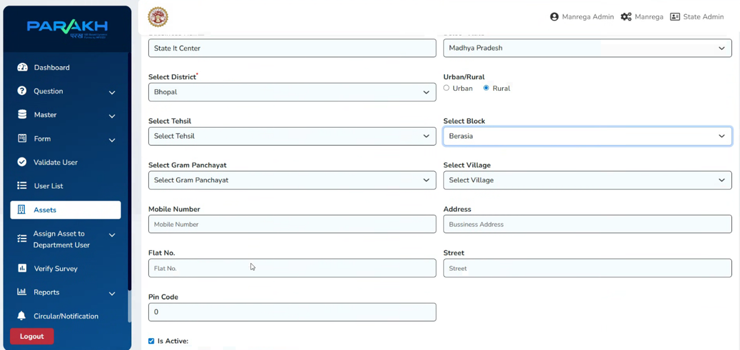

Step 8: Assign Asset to Department User
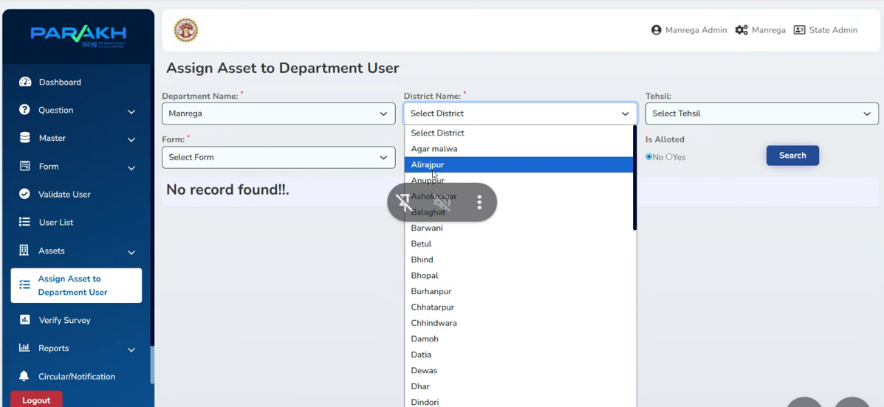

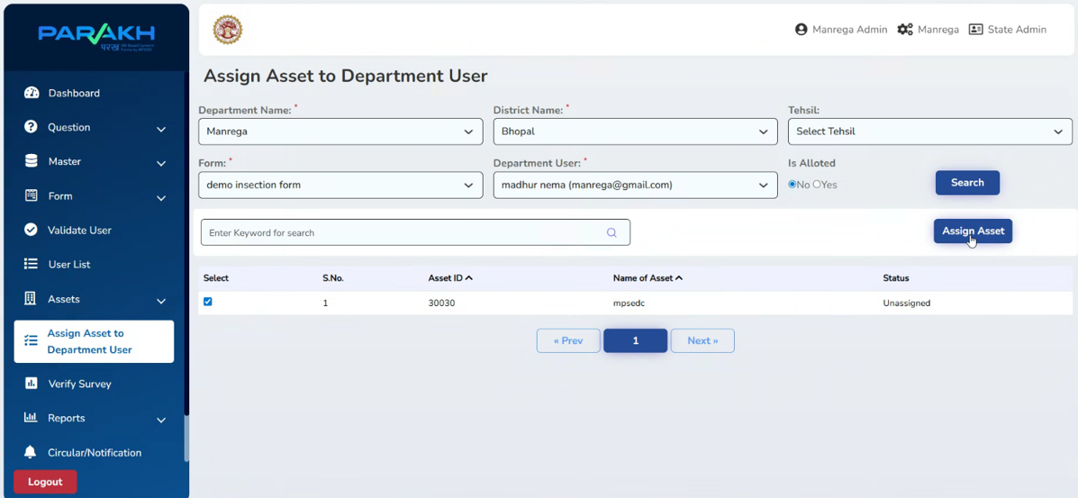

Step 9: Fill Forms on Mobile Interface
- Forms are available to mobile users based on type of person (Inspector, Citizen, Department staff)
- Data submitted is automatically collected in central database.

==============================================================================

Dynamic Form Created (Filling) Steps on Mobile Interface:

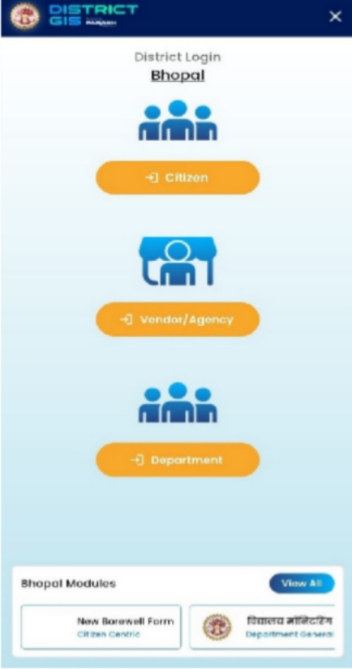
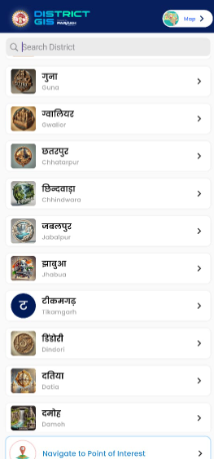
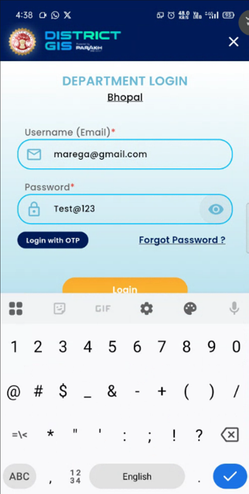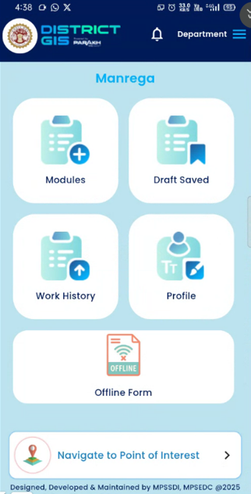

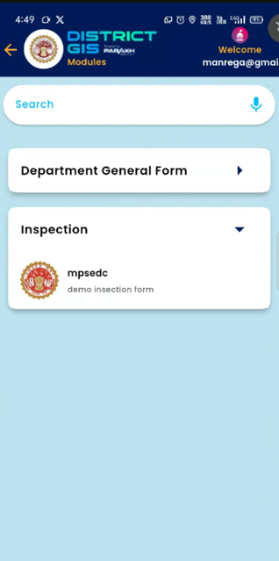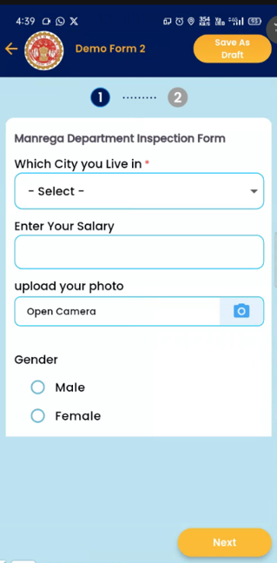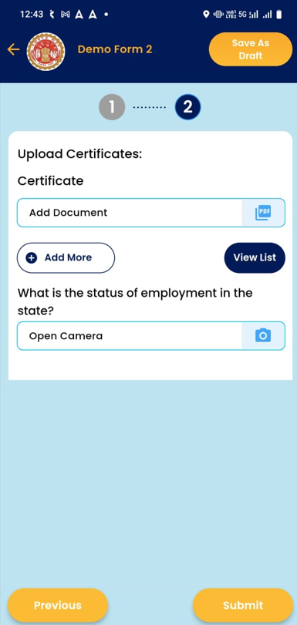

5. Validation & Exception Handling
Form Validation Rules
- Mandatory fields must be completed before submission
- Duplicate entries flagged
- Invalid user attempts logged
- Exception Handling
  - If survey data is incomplete → system prompts to re-enter
  - If user not approved → cannot access forms
  - If network failure → data stored offline & synced later

6. Compliance & Audit Guidelines
CMMI Level 5 Compliance ensures:
- Continuous improvement in form workflows
- Performance monitoring of survey/inspection processes
- Data governance and traceability of form submissions
- Standardized approval processes for user management

Dynamic Form Creation Manual follows CMMI Level 5 practices by ensuring process standardization, validation, continuous improvement, and traceability.

